**Hybridspectral Alternative for Remote Profiling of Optical Observations for NASA Satellites (HARPOONS)**

**Carlos E. Del Castillo1**, Stanford Hooker1, John Moisan1, Tiffany Moisan1, Roy Armstrong2, John Morrow3, Raphael Kudela4, Jim Brown5, and Koji Suzuki6

1NASA Goddard Space Flight Center, 2Department of Marine Sciences, University of Puerto Rico, 3Biospherical Instruments, 4University of California, Santa Cruz, 5University of Miami, 6Hokkaido University

We are developing a compact, mobile, and autonomous optical system to meet or exceed the optical in situ calibration performance requirements established by the PACE Science Definition Team. HARPOONS has been under development for ~10 years through NASA investments in various Small Business Innovative Research (SBIR) and Internal Research and Development (IR&D) projects. As a result, most subsystems are at TRL 6 or higher. Here we propose to take several of the sub-systems at TRL < 6 through a technical development process to TRL > 6. The HARPOONS system integration and field commissioning will be done off Kawaihae Harbor (HI) followed by ocean deployments off Lanai (HI) for comparison with MOBY. After completion of these oceanic deployments, HARPOONS will be operationally demonstrated in clear waters off the southwest coast of Puerto Rico, near the field station of the Department of Marine Sciences, University of Puerto Rico (UPR). The goal for HARPOONS deployment logistics is to maximize the collection of data during satellite overpasses while minimizing deployment costs. HARPOONS will be 100% commercially available, and simple and inexpensive to operate relative to present technologies. This will allow domestic and international partners to deploy additional systems at various locations, helping to further maximize the collection of vicarious in situ calibration data.

C-OSPREy





**Figure 1.** The HARPOONS system showing the Optical profiler tethered to the Wave Glider. The above water radiometer is shown on the Wave Glider. The C-OSPREy system will be deployed at the field Station in La Parguera ~ 15 nmi from the in-water measurements site.

## System description

HARPOONS has four components (**Figure 1**): a) a Wave Glider (WG) autonomous vehicle; b) an above-water global solar irradiance instrument (spectrally matched to the in-water system) to be mounted on the WG); c) a Compact-Hybridspectral Radiometer (C-HyR) optical package (integrated to and towed by the WG) that periodically slowly profiles between the surface and ~5m; and d) a Compact-Optical Sensor for Planetary Radiant Energy (C-OSPREy) mounted on a fixed stationary coastal platform near the vicarious calibration site.

**The above-water global solar irradiance instrument**

This hybridspectral instrument has 18 highly accurate silicon photodetector (SiP) microradiometers with 10 decades of dynamic range spanning 320–875 nm plus a Compact Grating Spectrometer (CGS) with 2,048 pixels spanning 190–1,050 nm that exceeds next-generation vicarious calibration requirements. The CGS comprises an imaging grating, optical port, and a CCD detector with electric shutter to minimize integration times. The instrument is compact (74×30×76 mm3), thermally stable, and has a Full Width at Half Maximum (FWHM) less than 2.2 nm (UV–VIS) and 2.5 nm (NIR). The spectrometer core is a blazed, flat field grating for light dispersion and imaging. The CGS has excellent stability coupled with very low stray light and high reliability in rough environments. The TRL is 3, we propose to take it to a TRL> 6.

**The in-water optical profiler (C-HyR)**

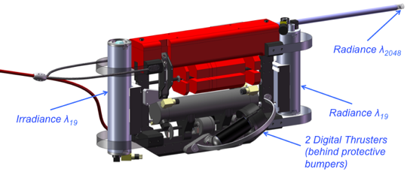

**Figure 2.** The in water optical profiler to be towed by the Wave Glider.

The C-HyR profiler (**Figure 2**) has three optical apertures and a pair of digital thrusters for maintaining viewing angle stability. The first optical aperture contains an upwelling Radiance Collector Assembly (RCA) for making hyperspectral (CGS spectrograph discussed above) observations very close to the sea surface. To ensure accurate measurements of highly attenuated wavebands near the sea surface, the diaphragm of a high-resolution pressure transducer is located adjacent to the radiance aperture of the RCA.

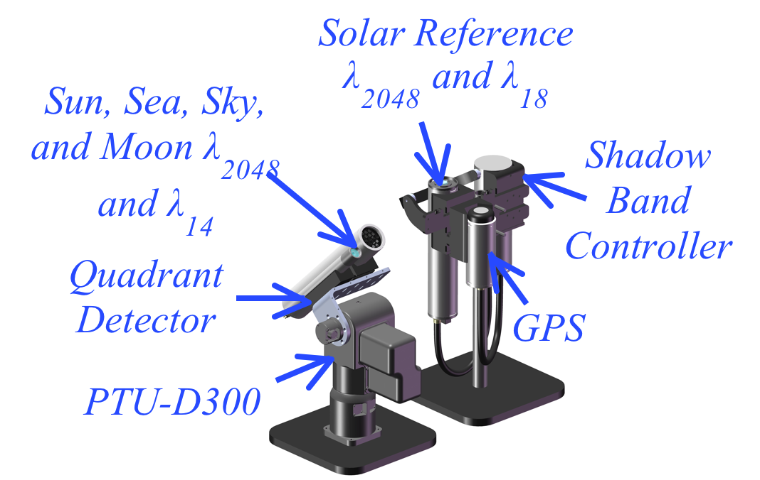

**Figure 3.** C-OSPREy with main optical components. C-OSPREy would be deployed on the rooftop of the Bio-optical laboratory at the field station of the Department of Marine Sciences ~ 15 nm from the HARPOONS deployment area.

The second and third optical apertures are for a downward irradiance and upwelling radiance, *Ed* and *Lu*, respectively, sensors. Both instruments are standard 19-channel SiP microradiometers spanning 320–875 nm with10 nm bandwidth. The use of the CGS spectrograph in the solar reference and RCA allows for the derivation of hyperspectral water leaving radiances, *LW* (λ), plus normalized forms, e.g., *Rrs* and [*LW* ]N per NASA protocols. The Ed observations are used in the determination of the extrapolation interval, and the *LW* microradiometer measurements are used to independently verify the overlapping CGS *LW* determinations, which include a recursive self-shading evaluation involving the RCA *Lu* observations. The profiler has a kite-shaped backplane with tunable ballast, a hydrobaric buoyancy chamber, plus pitch and roll adjustments, to provide unprecedented stability and vertical resolution in near-surface waters. The profiler data are of sufficient resolution and quality to show that the uncertainties in the execution of data sampling protocols are measurable at the 1% and 1 cm level. The optical profiler has a TRL > 6, but the CGS spectrograph to be added to the system has a TRL = 3.

**The Compact-Optical Sensors for Planetary Radiant Energy (C-OSPREy)**

A C-OSPREy (**Figure 3**) instrument will be deployed on the coast near the in-water vicarious calibration station. It provides calibration and validation data from fixed platforms, and will be used for photometry measurements in support of atmospheric characterizations. The C-OSPREy is autonomous and is pointed using a COTS military-grade tracker and a quadrant detector to measure the Sun and sky, plus the Moon for diurnal measurements and stability monitoring. The hybridspectral coverage is 190–1,050 nm (CGS) and 320–1,640 nm (SiP), with the former including a filter wheel for 3-axis polarimetry. The protocols for solar and lunar tracking, as well as the derivation of atmospheric data products from sky measurements, are provided by Hooker et al. (2012) and permit the derivation of the aerosol optical depth (AOD), aerosol single scattering albedo (SSA), total column, and precipitable water vapor (PWV). C-OSPREy is a mature system (TRL > 6), but for this application we need to integrate into it a neutral density filter-wheel subsystem which has a TRL = 3.

**The Wave Glider**

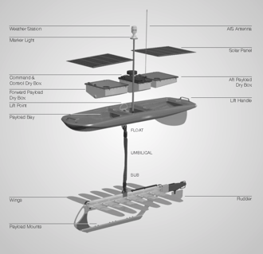

**Figure 4.** The Wave Glider. Picture shows all the main components of a standard system. The above water irradiance sensor will be mounted on the glider’s float.

The Liquid Robotics WG (**Figure 4**) is a wave-powered surface vessel, with the advantage that it is almost never becalmed because it harnesses energy from ocean waves of very small amplitude. In calm and rough seas alike, the WG is able to maintain a headway of ~1–2 knots along an assigned course or keep station to within a 40 m watch circle. It has been ocean-tested, from carrying out Pacific Ocean crossings to covering over 2,700 nautical miles in the Arctic, while recording and transmitting nearly 900,000 temperature measurements.

A WG consists of a surface Float plus an underwater Sub joined by a 6 m umbilical with electrical and strength members. Its propulsion technology utilizes wave energy for thrust and solar panels for charging batteries. The thrust mechanism is purely mechanical and provides limitless propulsion. The batteries provide power for command and control electronics, a thrudder module, plus payload sensors in the Float and Sub, or towed behind either (the proposed C-HyR system is towed behind the Float). The core electronics include a GPS for precision navigation, long and short-range communications, a weather station, and an Automatic Identification System (AIS) receiver, which is used for collision avoidance If payload sensors are mounted on or towed behind the Sub, power and telemetry is via the umbilical; otherwise power and telemetry is via the Float (the most expansive option, which is used here). A WG is two-person portable, air-freight compatible, and can be deployed using a small boat or dock (water depth permitting), so it can be deployed rapidly in remote locations. A WG is a robust platform (one survived Super Storm Sandy while collecting data) and are already used to tow underwater instrumentation in operational settings. The towing capability has been tested under relevant operational conditions, so the TRL of the WG is 9.

**Project Status**

Through the end of the first six months of the project we have completed the procurement of all major hardware and taken delivery of the latest generation WG. Fabrication of the optical profiler and OSPREy system is proceeding on schedule. Preliminary data collected in North Pacific with a prototype C-HyR profiler (Figure 5) shows the system is performing as expected, wherein the larger dark circles are the SiP microradiometers and the smaller light circles are the CGS spectrograph. The data at the lower end of the PACE domain of 350-900 nm, distinguish this technology beyond PACE requirements. The data were collected within a coastal water mass as part of a joint campaign with our Japanese collaborator Dr. Koji Suzuki aboard the R/V *Hakuho Maru* (KH-15-1). Although pigment analyses for the contemporaneous water sample are not available yet, the data were obtained in eutrophic conditions. The spectra are from a water depth of 0.3–1.5 m and establish an ability to collect data at near-surface depths and obtain good results. The platform orientation for the spectra are pitch to within 0.6° and roll to within 3.3°, i.e., to within a vertical tilt of 5°. The spectrograph integration time was 100–200 ms. A profile extending down to as little as 1 m (this profile goes to a bit more than 3 m) allows our state-of-the-art data processor (PROSIT) to derive all the usual data products, e.g., *LW*, *Rrs*, [*LW* ]N, the OC band-ratio products, etc., so the anticipated 5 m profiles from the WG will be sufficient for mission success. The spectrograph data reveal challenges in the NIR, but there are sufficient data for signal processing and the number of SiP microradiometer NIR channels will be increased to improve data quality at low signal-to-noise levels.

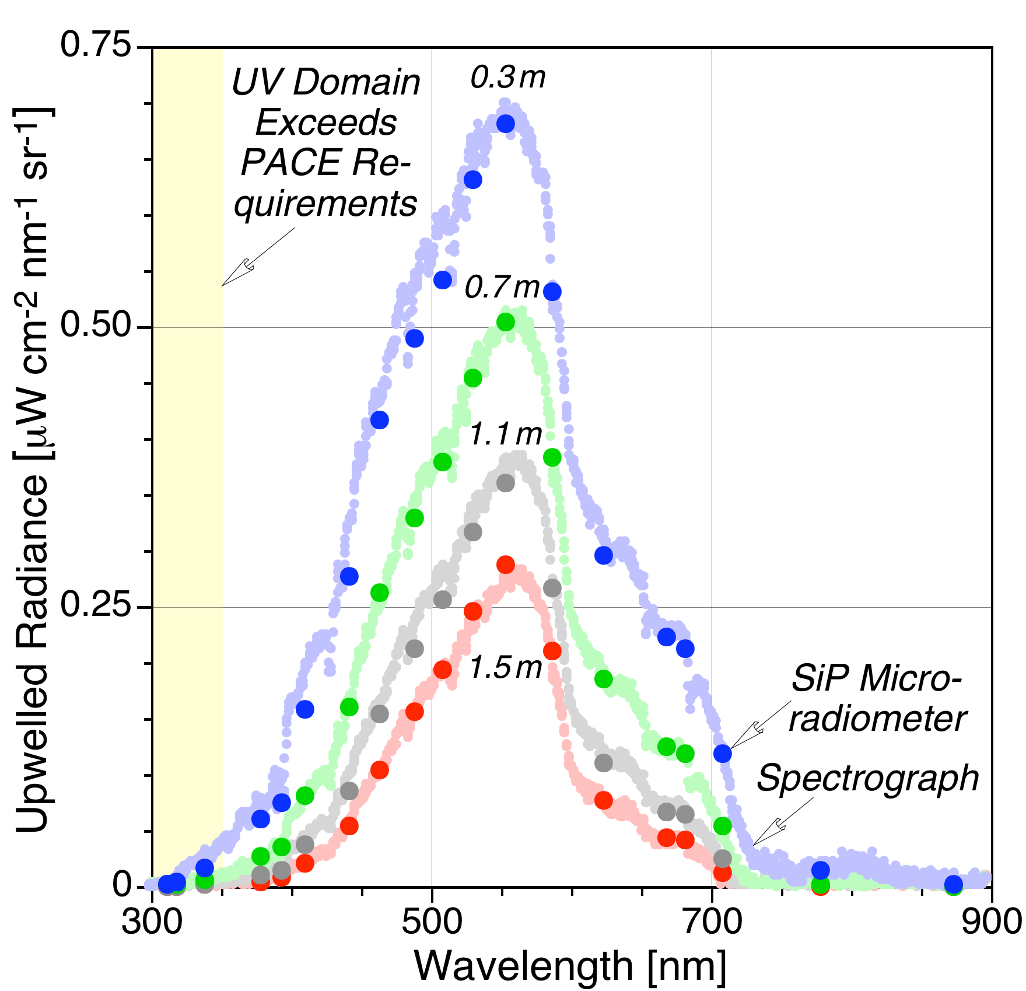

Figure 5. Example of data collected with the C-HyR profiler on board the R/V Hakuro Maru.